Zest-Ware

User Documentation

ivan marsic | *Professor – Software Engineering*

*Alexander Dewey | Ama Freeman | Dwayne Anthony Fahd Humayun | Nathan Morgenstern | Raphaelle Marcial Shehpar Sohail*

2017

Table of Contents

Customer: 3

1.1. Making A New-Reservation: 4

1.2. Making A New-Reservation (Alternate Scenario): 13

2.1. Checking Reservation: 16

2.2. Checking Reservation (Alternate Scenario): 19

3.1. Making A Pre-Reservation: 20

3.2. Making A Pre-Reservation (Alternate Scenario): 23

# Customer:

On the Customer Welcome Screen (CWS) there are two options “Pre-Reservation” or “New-Reservation”:

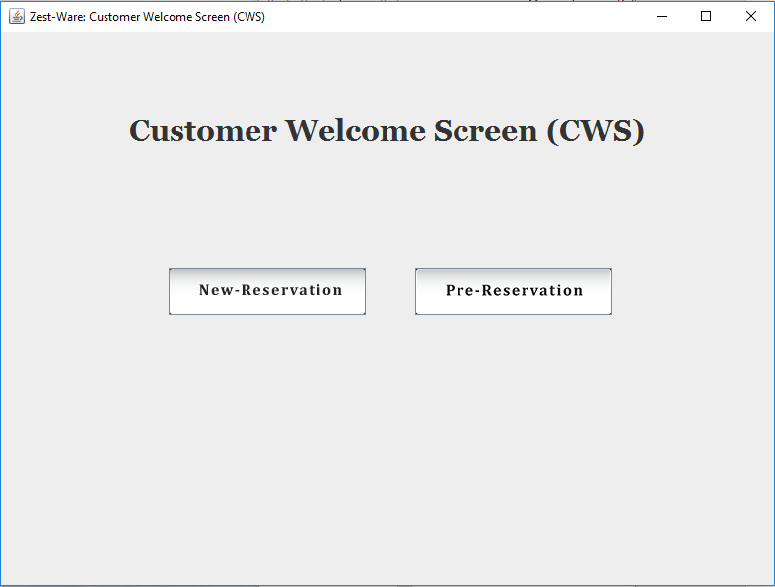

## 1.1. Making A New-Reservation:

Select the “New-Reservation” option to create a new-reservation, which will bring to new different screen for inputting information.

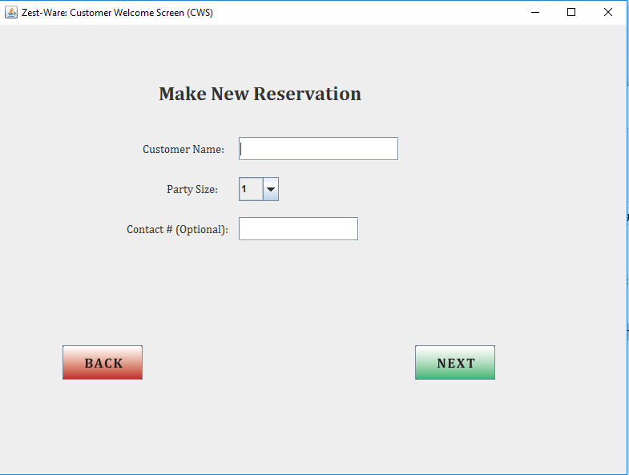

Enter the customer name and party size into the respective fields. The contact # is optional and may be implemented later for final demo.

To enter the party size, click on the drag down arrow on the right of “Party Size.” By default, there will be 4 numbers shown (the max table size is set to 4 for now) that will represent the party size.

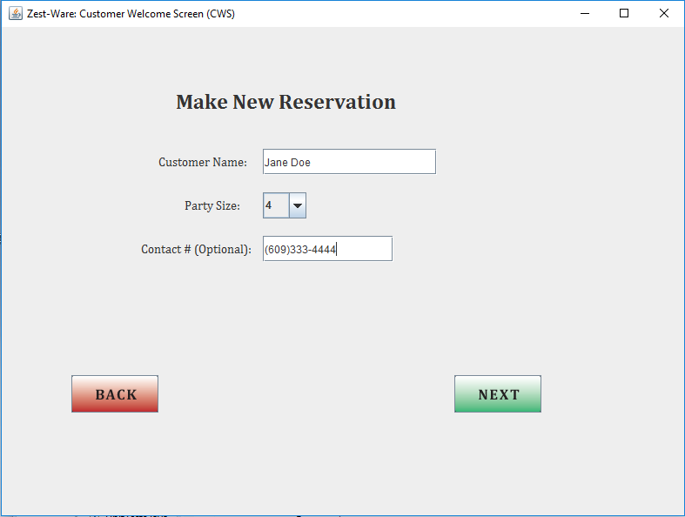

*The keyboard will pop up for input:*

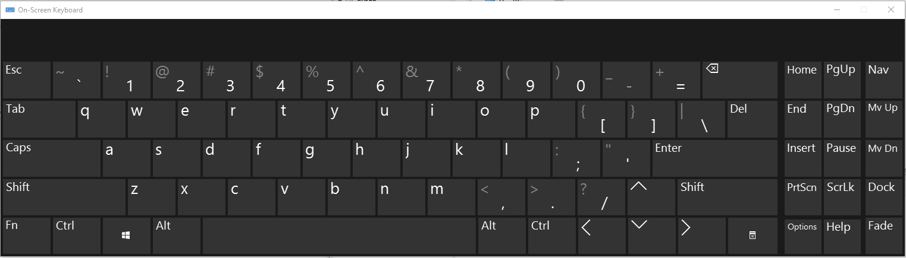

The BACK and NEXT can be used to either go to the previous screen or proceed to next screen after giving input. If the name is not entered and NEXT is selected a message will be displayed asking for the name to be entered.

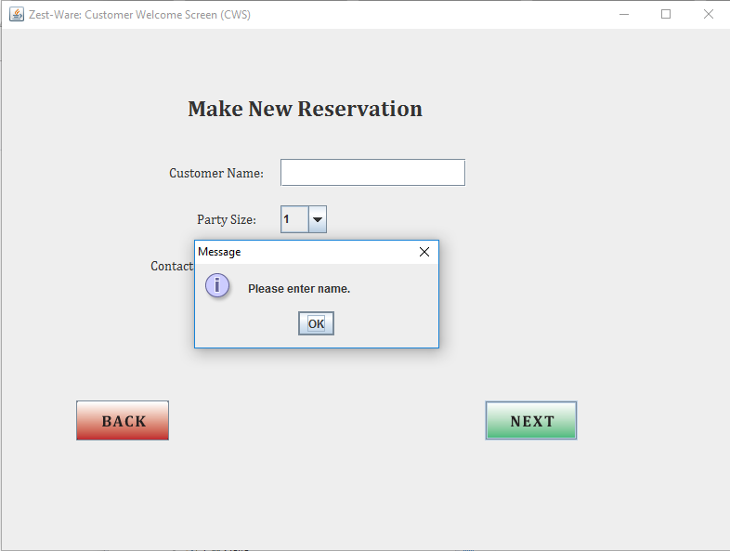

To enter the party size, select the appropriate size in the drop-down menu by scrolling up and down the options.

When the user tap NEXT the seating chart would show on the next screen as follow:

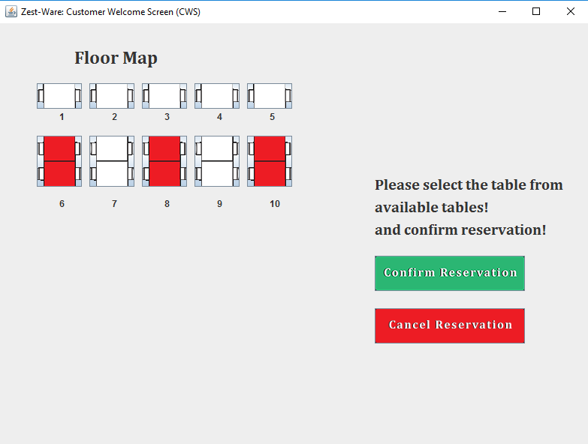

The user can select the table of their choice by selecting one of the available tables.

If the user selects a table that is not available, the system would pop up an error message again.

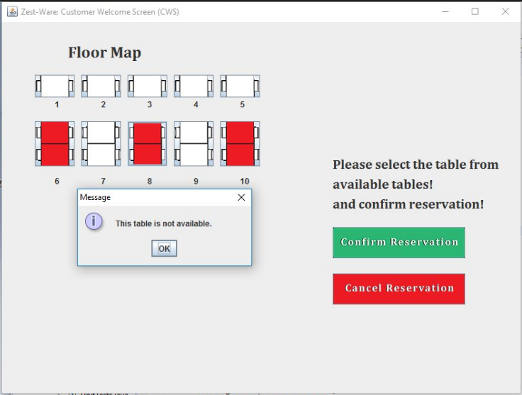

If the user selects a table that is available but not suitable for the size, the system would pop up an error message again.

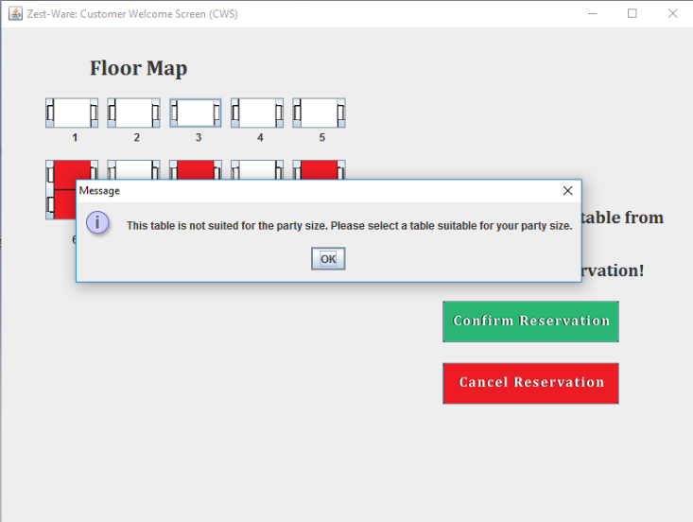

Once the user selects a table that is suitable and available the table icon would change to green, the user can change another available table and then that table icon would change to green.

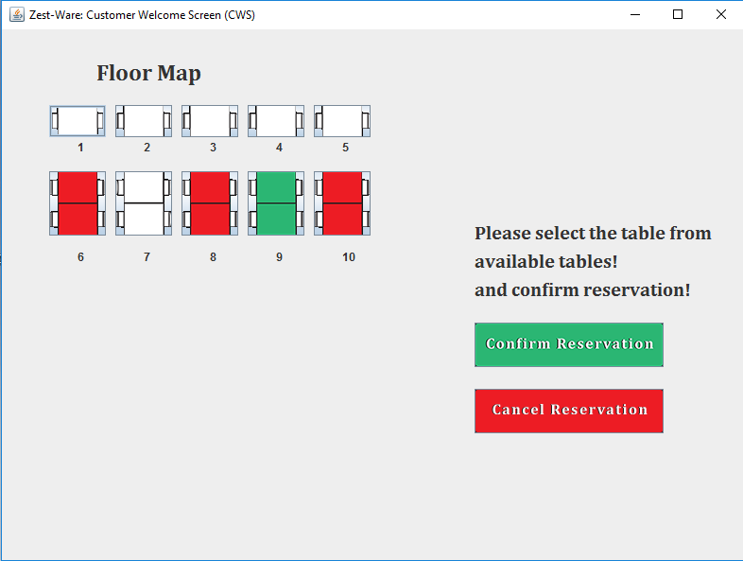

The user/customer can either confirm reservation or cancel the reservation by selecting the respective option. When the confirm reservation is selected a screen will pop up that will display a message of the reservation being made, and by selecting cancel reservation the main screen of CWS will brought up.

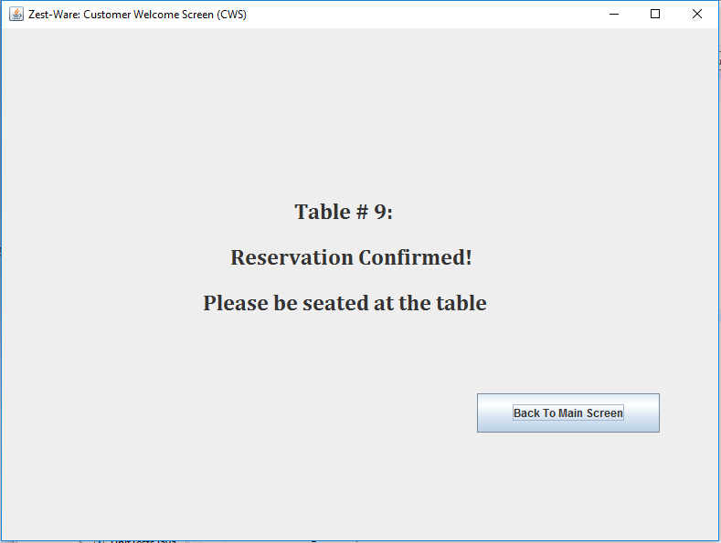

*Note:*

*After selecting the confirm reservation the information of customer i.e. the customer name, the party size, contact number (if any), the table number assigned to the customer and the time reservation has been made are stored into the database. This information will then be used to check for overlapping or putting the requested reservation in a queue if no tables available. There are 10 tables right now according to the screen mock-up of floor mapping system that was shown in the prior report submissions. So, the tables have been kept as 10.*

*The screenshot of profiles table in database before the addition of the new reservation*

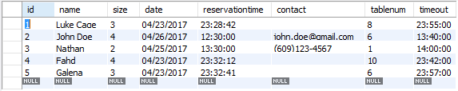

*The screenshot of profiles table in database after the addition of the new reservation*

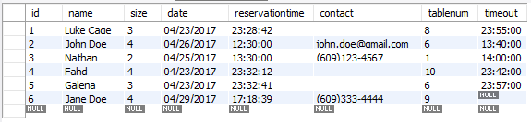

## 1.2. Making A New-Reservation (Alternate Scenario):

If the user is making a new reservation and no tables are available.

The user as before enters the information for making new reservation:

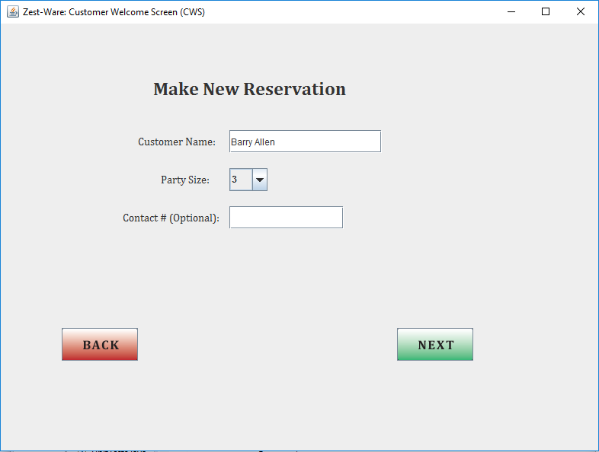

After tapping NEXT, if there are no tables available, the system calculates the estimated wait time, and the next table to be available soon and displays the next screen as follow:

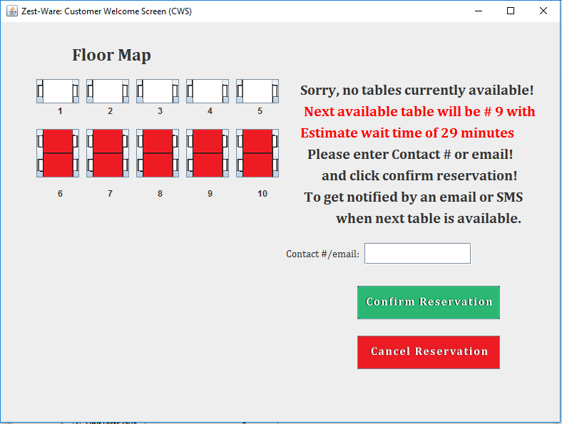

*Note: the wait time is calculated by going through each customer in the database that has made reservation and has left the restaurant, in the database there are two columns one for reservation time and the other for timeout, so the system takes those two times, gets the difference, and gets the average of all those differences. The next table available is predicted by the table occupied first by the customer would likely be leaving soon.*

After the user enters the contact number and confirms reservation.

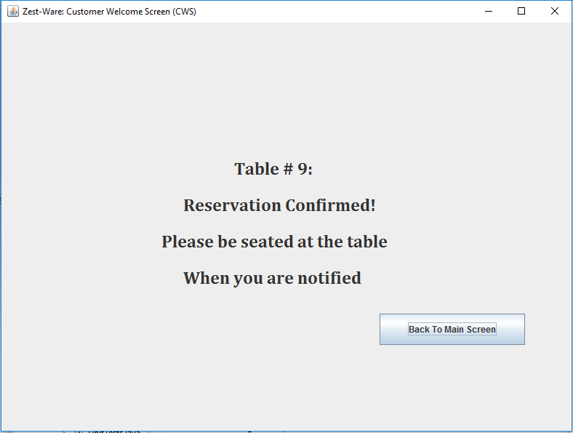

## 2.1. Checking Reservation:

The user taps on the Pre-Reservation button on the main screen of CWS, the system displays two more option i.e. Make pre-reservation or check reservation.

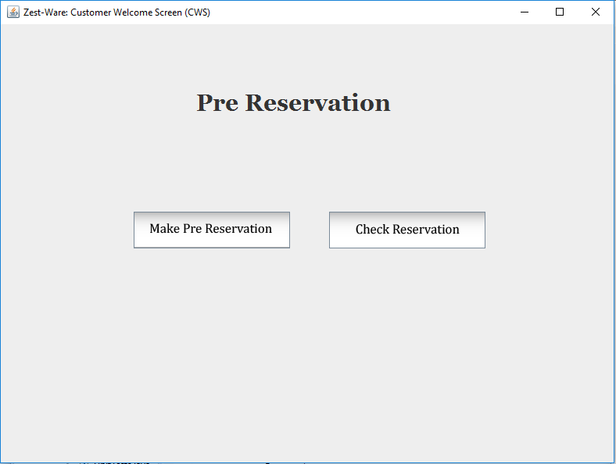

The user taps on the check reservation and the system asks for user input.

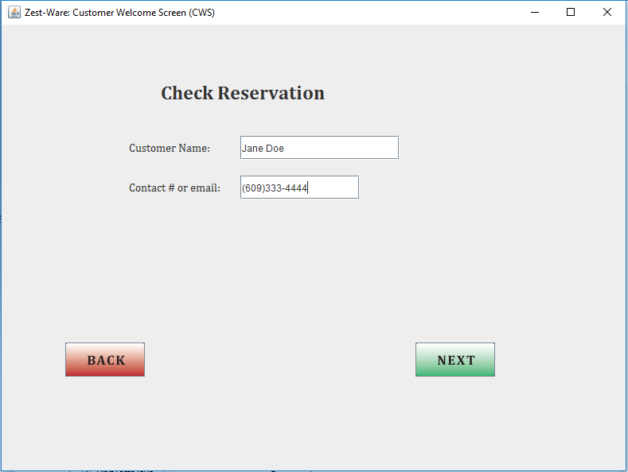

If there is reservation made on that information the system would display the details.

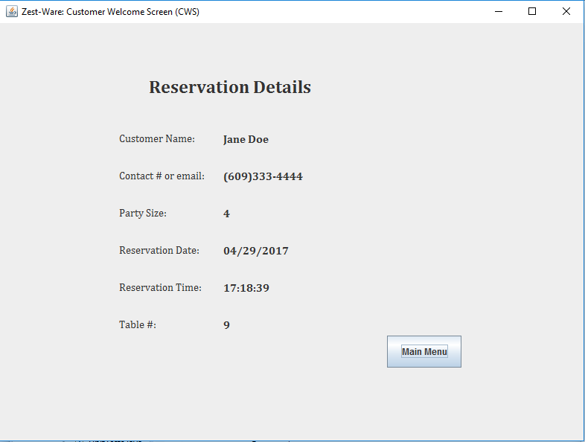

*The system can check both with the email or contact number which ever is provided by the customer while making the reservation.*

## 2.2. Checking Reservation (Alternate Scenario):

*If the information entered does not match any reservations made the system displays a message.*

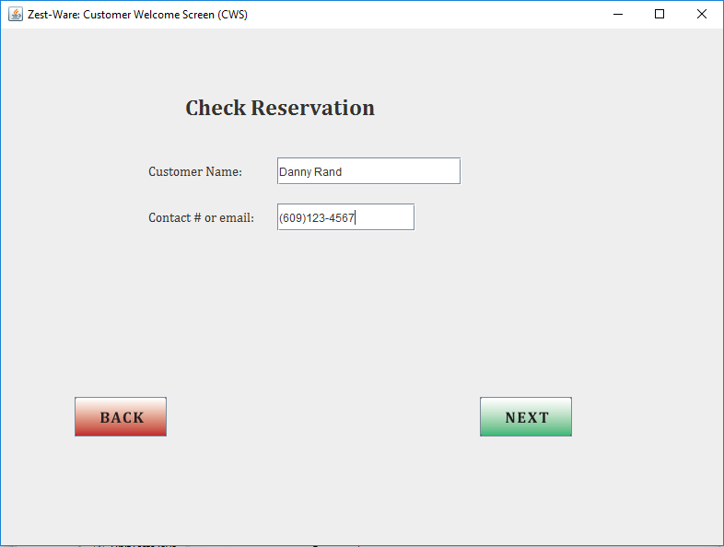

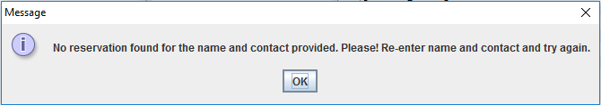

## 3.1. Making A Pre-Reservation:

The user taps on the Make Pre-Reservation button on the pre-reservation screen of CWS, and the system displays a screen asking for user to enter information, and the user enters information needed.

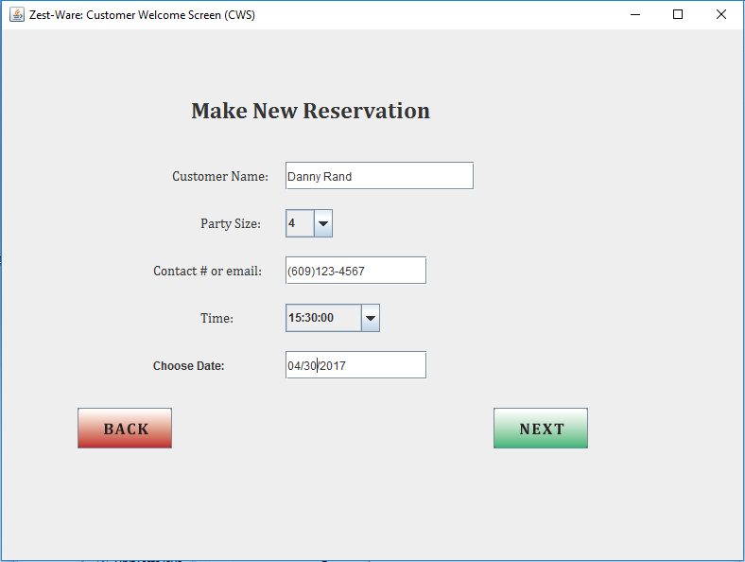

*If any of the information is missing the system would display a message asking for the user to enter that specific information.*

If a table is available for the reservation time, the system would confirm reservation and displays it on the screen.

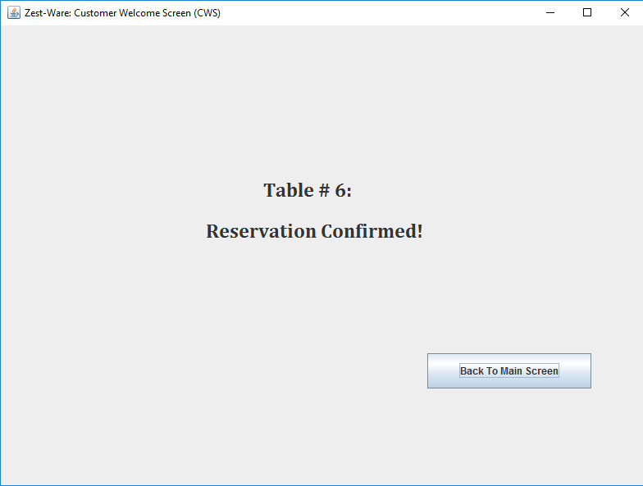

The details can now be check by going to the check reservation option and entering the information.

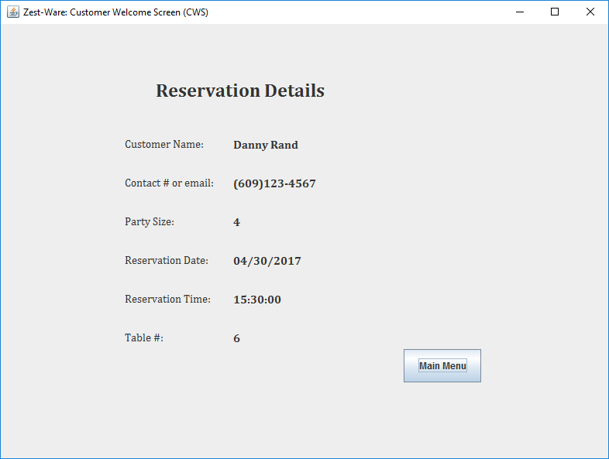

*Screenshot of database:*

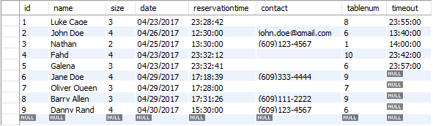

## 3.2. Making A Pre-Reservation (Alternate Scenario):

If the user is trying to make a reservation and there are no tables available for that specific date and time, the system would display a message.

To check this the database has been updated as such that there are no tables available for a specific date and time, then the user tries to make reservation for that specific date and time.

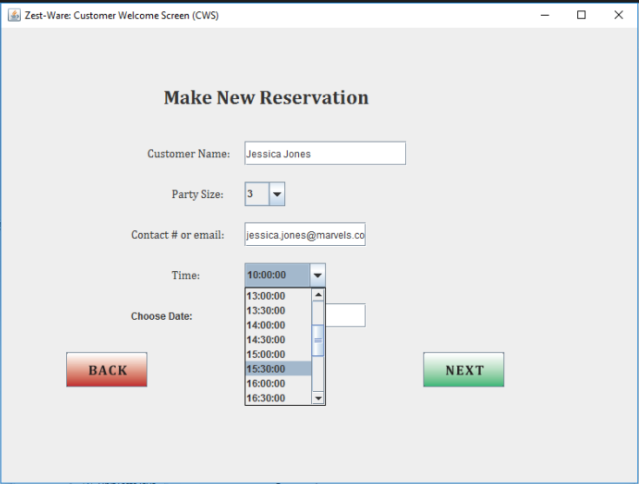

*Screenshot of database:*

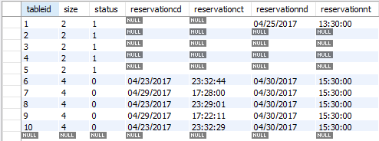

*Error message after tapping NEXT*

